Omiga .NET Refresh
Statement of Work

Darren Santaeulalia
Business Technical Services
Version: 1
Date: 19th November 2007

For Circulation to:

Andy Green
Adrian Stanley
James Colley
Lee Harrison
Will Owen
Kevan Gleeson

Contents
1. Project Information 3
2. Project Background 4
3. Overview of Requirement 5
4. Impact assessment 11
5. Procurement information 15
6. Proposed Roles \ Responsibilities 16
7. Initial Response 17
8. Project Controls 20
9. Initial Project Plan 21
10. Quality Plan 22
11. Change Control 23
12. Configuration Management 24

Project Information

RFS Title
Omiga .NET Refresh

Date RFS approved by Governance
7th November 2006

RFS Reference Number
318310

RFS Requester \ Project Sponsor
Andy Green | Julia Murphy

BTS assigned BTM \ assigned Lead Technician
Darren Santaeulalia | Lee Harrison

Requested Delivery date \ Proposed delivery date
N\A | 14th January 2007

Estimated Effort in Hours \ Out of hours
251.5 hrs | 0 hrs

Project Background

Product Description
The delivery of a Development infrastructure that will support the migration of VB6 code to .NET C#.
The upgrade of the desktop platform for the Mortgages business unit to support the migration of VB6 code to .NET C#.
To provide the infrastructure for Vertex Staff located in AiS offices within Costa Rica to access the MSG domain and services
To provide a development platform to support the rearchitechture of Omiga

Project Objectives
1. To ensure that Vertex Staff located in Costa Rica (AiS) offices have the abililty to connect to the MSG Domain to complete their technical objectives with regards the migration of VB6 code to .NET C#
2.To develop a desktop upgrade refresh strategy that will have minimal impact to the business
3. To ensure that there is a secure mechanism in place to support the transfer of file and code between AiS and Mortgages
4. To build\ deliver a Developement infrastructure that will support the migration of VB6 code to .NET C#
5. To provide Mortgages the support environment required to ensure the re-architecture of Omiga can progress
6. To ensure that BTS can support new technologies introduced to the MSG infrastructure
7. To complete a controlled operational Handover to BAU support
8. To ensure a controlled delivery strategy is adopted by BTS

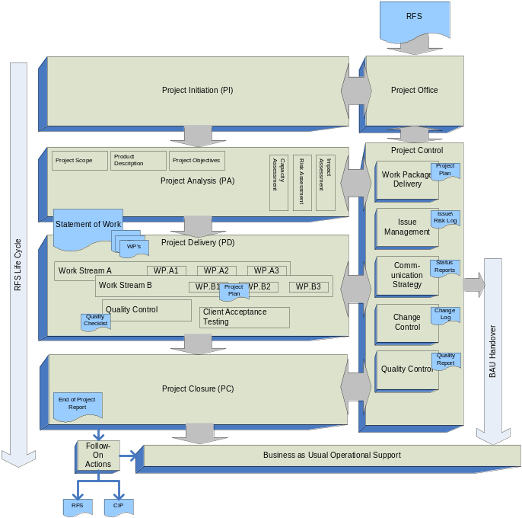Project Life Cycle
- RFS
- BTS Project Initiation
- Project Analysis
- Statement of Work sign-off
- Project Delivery
- Internal Quality Control
- Client Acceptance Testing
- Operational Handover
- Project Closure
- BAU

Overview of Requirement

Technical Overview

Technical Architect
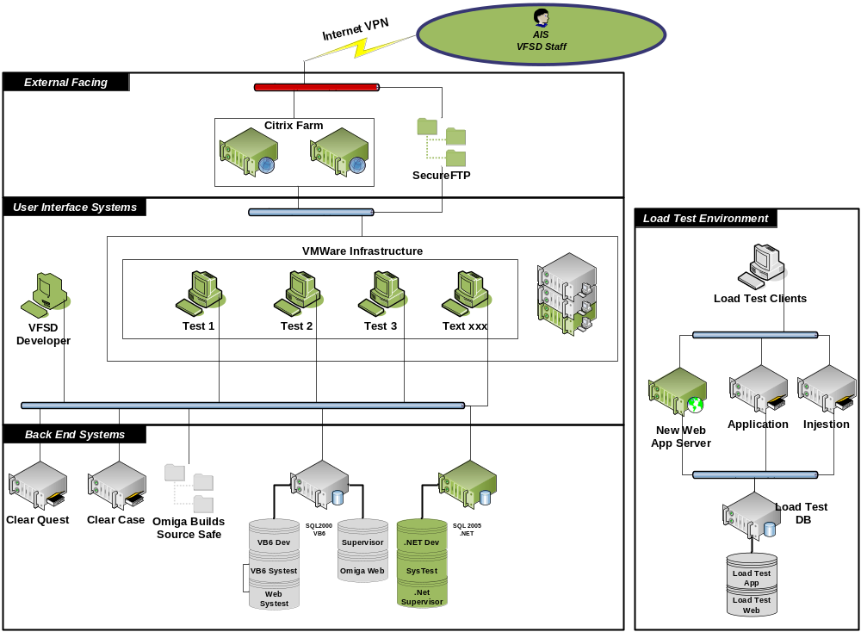

Technical Infrastructure Breakdown

Location details
- The Development infrastructure being implemented by BTS to support the VB6 migration will be hosted in:
Vertex Financial Services
Jessop House
Cheltenham
GL50 3SH

Citrix
- Mortgages Staff located in Costa Rica during the migration will have access to VFS services via the Citrix Portal http://fsdportal.vertex.co.uk

- The following applications will be published to dedicated Mortgages staff that will be located in Costa Rica (AiS)
  - Office\Email
  - RDP
- AiS will ensure that the Mortgages Staff will have access to the internet

VMWare

8 x Vertex Test Virtual Machines to be built to the following spec.

1 GB RAM

20 GB HDD

Windows Server 2003 Service Pack 2 (32 bit)

SQL Server 2000 client tools

SQL Server 2005 Standard edition license
The following hardware will be procured to support this environment:-
- PL585 G2
- CPU – 2x1MB Dual Core
- Memory – 16GB
- SAN Attached

Please note for phase 1 – W2008 \ SQL2008 will be out of scope
The delivery of 2 x images will be delayed until the release of Longhorn (Scheduled 27/02/2008)

Build
A new build PC will be built to be dedicated to this migration project. The software includes:
- Windows Server 2003 Standard. It is important to ensure the release builds are generated on the same O/S as the target environment.
- Visual Studio 6 Service Pack 5.
- Visual Studio 2003 Service Pack 1.
- Visual Studio 2005/2008.
- .Net Framework 1.0 Service Pack 3.
- Source Safe client.
- ClearCase client.
- FinalBuilder 5.
- InstallShield.
The following hardware will be procured to support this environment:-
- HP dc5750
- Disk – 250GB
- Memory – 2GB

Back End Systems
SQL Data-store
Software:
- Windows Server 2003 Standard Service Pack 2 (32 bit)
- SQL Server 2005 Standard Edition Service Pack 2 (32 bit)
Hardware Platform:
- BL685 cClass 4x1MB Dual Core
- Memory – 4GB

Load Test environment
App\Int server
Software:
- Windows Server 2003 Standard Service Pack 2 (32 bit)
- SQL Server 2005 Standard Edition Service Pack 2 (32 bit)
Hardware Platform:
- BL685 cClass 4x1MB Dual Core
- Memory – 4GB
SCH018668
- Current Load test SQL server will have SQL2005 installed to support the load test environment for the migration project
- SQL Version = SQL2005 Standard edition SP2 (32bit)
- This is to be installed along side the current installation of SQL2000

Desktop Infrastructure
Details of the desktop upgrade \ refresh will be confirmed as the output of Work package F1. Desktop Strategy.

SAN
ESX
- 300GB will be allocated to support:
  - 10 x VM’s (20GB OS required)
SQL
- 600GB will be allocated to the SQL Datastore configured as:
  - 300GB Data
  - 200GB Backup
  - 100GB Logs
SourceSafe
- An additional 10GB will be required to be added to the current SourceSafe data share
- The current Share location has been confirmed as being able to support this increase in quota

Security
- Vertex standard security policies will be enforced
- SFTP will be used to transfer secure attachments \ code from VFS to AiS and vice-versa
- Secure email has not been requested

Domain
- All environments that BTS will deliver will be hosted within the MSG domain.
- No Services are required from within the VFSD domain to support the Omiga .NET refresh infrastructure.

Backup
- The following servers will be placed on the Standard VFS Short Store Backup policy
  - SQL Data-store Server
    - SQL Agent to be used
  - Load Test Server
    - Standard Legato License

Vertex Services
No Additional services are required from Warrington

Product Breakdown
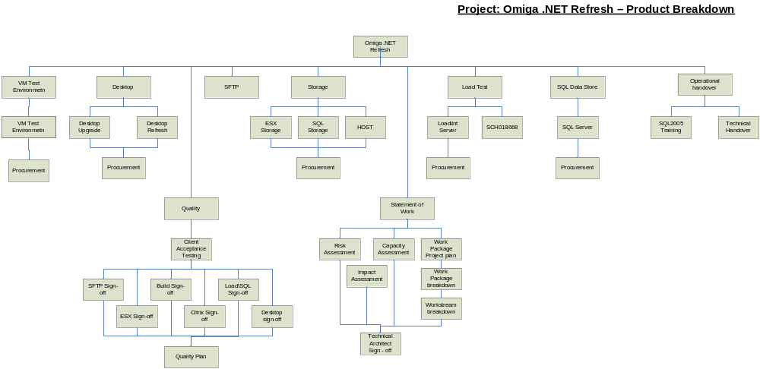

Flow Diagram
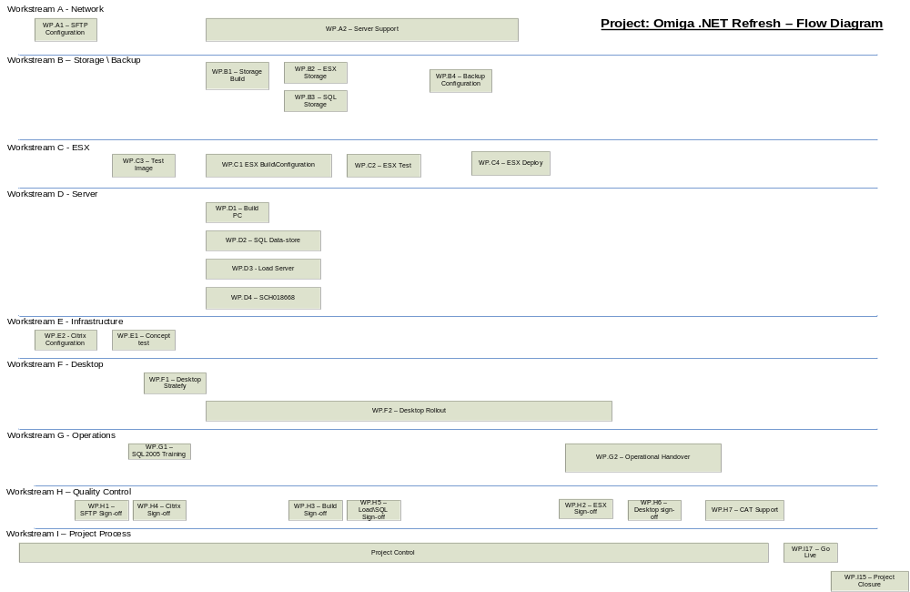

Impact assessment

Commercial Impact

Operational Support
It is estimation that approximately 9.5hrs per month will be required from the BTS operational teams to support the additional infrastructure that the Omiga .NET refresh project will implement

This figure relates to 6.3% of an FTE.

Based on an average salary of £25,000.00 the FTE cost to support the additional Omiga .NET Refresh infrastructure will be £1,575.00

Training requirements
To ensure that BTS can support the technology that the Omiga .NET Refresh roadmap it is deemed that the following external training will be required:
  - SQL2008
  - Windows 2008
  - Approx cost £4,000.00 will be required to support this training need
- Please note that formal quotes will have to be obtained to confirm cost

Operational Impact

BTS Resource Impact
- It has been identified that the following training needs will be required for BTS to continue to provide operational support to these environments:
  - SQL2005
- Going Forward BTS will be required to potential support the following platforms
  - Windows 2008
  - SQL 2008
  - 64bit hardware

Risk Assessment

Operational Risk
- No SQL2005 experience within BTS
- Dependant on 3rd Party to provide internet access for Vertex staff located in Costa Rica
- BTS support hours will not support Costa Rica working hours (GMT -6)
- Ability for BTS to support VFS assets located in Costa Rica

Project risk
- Procurement delivery date unknown
- Christmas Change freeze scheduled 20 December 2007 – 3rd January
- Concept test required to be schedule prior to go-live
- Dependant on the C classis being delivered \ installed

Strategic Risk
- MSG\VFS Assets not insured outside of Vertex premises
- BTS may by subject to an internal organisational review \ restructure
- Dependant on the Power upgrade to Jessop House

Capacity Impact

Citrix
- No issues with regards capacity or licensing

ESX Tower
- Substantial hardware \ licences have been purchased to support the requirement

Storage
- Substantial hardware has been purchased to support the requirement

Server Tower
- Blade enclosure can support the additional blade server requirement

Environment

Power
- Following the power upgrade scheduled 25th November 2007, there will be sufficient power to support the additional hardware

Air Con
- The Air con will support the additional hardware

Rack Space
- There is sufficient rack space to support the additional hardware within the Gold server room –Jessop House Cheltenham

Dependencies
- Mortgage Resource to assist with the Desktop strategy upgrade planning
- Downtime for the developers during the desktop rollout is authorised
- Mortgage Resource to assist with the Technical sign-off for Workstreams
- Mortgages Resource to assist with the Client Acceptance testing and Sign-off
- Power upgrade to Gold – scheduled for 25th November
- Blade Chassis ‘Class C’ Delivered\built\racked\tested
- Nominated AiS staff member to assist with Concept test and sign-off

Assumptions
- No new user accounts are required
- AiS do not require access to VFS systems or services
- No other 3rd Parties will be involved or require access to VFS systems or services
- SQL2005 training will be scheduled prior to implementation
- Enhanced out of hours support is not required for the Vertex Staff located in Costa Rica
- No resources or services required from Warrington for offshore Vertex staff located in Costa Rica
- 100MB network speed required for load test and SQL server
- No DR strategy is required
- AiS will provide the offshore Vertex staff located in Costa Rica internet access

Out of Scope
- Windows 2008
- SQL Server 2008
- 64bit technology
- AiS support (Excluding SFTP)
- Implementation of internet access for Vertex staff working from within AiS

Procurement information
Procurement is being dealt with as a separate activity between:
- Governance
- Mortgages
- Procurement

Further details can be obtained from the VFS Procurement team.

Proposed Roles \ Responsibilities
The following roles\responsibilities are being proposed
- Any issues with these roles\responsibilities should be raised with the BTM or the Project Sponsor, who will address any concerns.

Project Implementation Responsibilities
Role | Person | Company | Comment
Project Sponsor | Julia Murphy | VFS – Mortgages
Project Manager \ Point of contact | Andy Green | VFS – Mortgages
Client technical contact | Simon Bajcer | VFS – Mortgages
BTS - BTM | Darren Santaeulalia | VFS – BTS
BTS – Lead Technician | Lee Harrison | VFS – BTS
VFS Governance | Will Owen | VFS - Central
Change control manager | Andy Green | VFS – Mortgages
Risk Ownership | Andy Green | VFS - Mortgages
License Ownership | Pete Evans | VFS – Central
Procurement | Katy Richardson | VFS - Central
VFS Asset Management | John Bartlett | VFS - Central
Operational Handover | Darren Santaeulalia \ Paul Hooper | VFS - BTS

Initial Response

Scope & High Level Estimates

ID | Description | Estimated Effort | Start | Finish
 | A. Workstream - Network | 12 hrs | 26/11/2007 | 21/12/2007
 | B. Workstream - Storage\Backup | 7 hrs | 10/12/2007 | 17/12/2007
 | C. Workstream - ESX | 52.5 hrs | 21/11/2007 | 20/12/2007
 | D. Workstream - Server | 37.5 hrs | 10/12/2007 | 14/12/2007
 | E. Workstream - Infrastructure | 6 hrs | 19/11/2007 | 30/11/2007
 | F. Workstream - Desktop | 64 hrs | 26/11/2007 | 07/01/2008
 | G. Workstream - Operations | 41.5 hrs | 03/12/2007 | 14/01/2008
 | H. Workstream - Quality Control | 11 hrs | 22/11/2007 | 11/01/2008
 | I. Workstream - Project Process | 62 hrs | 02/11/2007 | 25/01/2008
 | J. Workstream - Change | 15 hrs | 05/11/2007 | 25/01/2008
 | K. Workstream - Contingency | 15 hrs | 05/11/2007 | 25/01/2008
Total Estimated Effort (Hours) |  |  | 281.5hr
Total Estimated Effort (Days) |  |  | 37.5 days

Commercials

Project Days
Estimated Project days cost | £7,603.11
Please note: For cost model purposes please use the cost of:
BTM - £242.00 \ per day (7.5hr)
Senior Technician - £200.00 \ per day (7.5hr)
BTS Technician - £139.00 \ per day (7.5hr)

Tolerance Budget
Estimated Tolerance Budget | 30 hours
Please note: A Tolerance budget of 30 hours has been quoted to allow for contingency and flexibility of project delivery, this includes an estimated 15hours for a change of scope budget

Potential Out of Hours work
Task | Description | Justification | Effort
Total Estimated Effort (hours)
Total Estimated Effort (days)
Tolerance Out of hours budget |  |  | 10hr
Estimated Total Cost (£) |  |  | £400.00
Please note: The out of hours work requirement is an estimate and not a fixed price. Should unforeseen issues be encountered the cost may increase. Equally, should the work take less than the time indicated the cost would be reduced accordingly. The hours indicated would be charged at the standard overtime rate of £40 an hour.
Please note: A Tolerance budget of 10 hours of out of hours work has been quoted to allow for contingency and flexibility of project delivery.

Total Effort breakdown
Out of hours budget (Inclusive of Tolerance budget) | £400.00

Proposed delivery date

Proposed handover to Client Acceptance Testing | 7th Jan 2007
Proposed handover to BAU | 14th Jan 2007
Proposed customer project sign off date | 18th Jan 2007

Additional Expense (Estimated)
Hotel
Travel
Total Additional Expense | N\A
Please note: Additional Expenses are estimated and have not yet been quoted for.

Summary

Dates
Start | 2nd November 2007 | Finish | 25th January 2008

Duration
Scheduled | 65.07 days

Work Effort
Scheduled | 291.5 Hours

Estimated Implementation Cost
Implementation Costs | £7,603.11
Out of hours | £400.00

Additional Costs
Total Cost | £8,003.11
Please note: Estimated costs are provided for cost model purposes – Please refer to section 7.1.2(Commercials – Project days)

Project Controls

Meetings
Description | Purpose of Meeting | Frequency | Attendees
Project Review meetings | Review status report.  To assess the deliverables achieved against plan and the continued viability of the project. | As planned | BTS BTM  BTS Team Leader  Senior User (if required)
Project Closure Meeting | To ensure that all products have been delivered and all accepted | As planned | BTS BTM  VFS Project Manager

Description | Purpose of Meeting | Frequency | Attendees
Checkpoint Meeting | To assess progress against plan. Reports to be given by project team members. Raise new risks & issues. | As planned | Project team members

Reports
Description | Purpose | Attention of | Frequency
Status Reports | Produced to record progress | Project Board | Weekly
Lessons Learned Report | A report produced which provides details of the lessons learnt during the project which may be of interest on future projects | Project Board  BTS Team Leader | To be published within the End of project report
End Stage report | Stage report highlighting effort \ issues. | Project Board  BTS Team Leader | Not required
Project Closure Report | Final report detailing actual against forecast dates & costs. Will also detail residual actions required. | Project Board | At project closure

Initial Project Plan

Project pre-requisites
- n\a

Planning Assumptions
- Delivery of procurement is expected prior to 7th December
- Power capacity with Jessop House will support the additional hardware
- AiS will not require access to any systems within MSG\VFSD

Work Packages
- Complete Work packages can be provided upon request

Work Package Schedule
- Schedule Breakdown can be provided upon request

Initial Project Plan
- Project plan can be provided upon request

Milestones
Task | Delivery Date
WP - Citrix Sign-off | 22/11/2007
WP - Statement of Work | 23/11/2007
WP - SFTP Sign-off | 29/11/2007
WP - Build Sign-off | 13/12/2007
WP - Load\SQL Sign-off | 14/12/2007
WP - ESX Sign-off | 21/12/2007
WP - Desktop Sign-off | 07/01/2008
WP - CAT Support | 11/01/2008
Operational Handover | 14/01/2008
Go Live | 14/01/2008

Quality Plan

Quality Plan Schedule
- Quality plan and schedule to confirmed as the output of Work Package I9 – Quality Plan (Scheduled – 3rd December)

Acceptance Criteria
- Acceptance Criteria to be confirmed as the output of Work Package I9 – Quality Plan (Scheduled – 3rd December)

Change Control
Any additional requirements to this RFS will be required to follow a change control procedure that will require a change in the work estimate and authorisation from Governance will be required. Any change requested may require the delivery date to be renegotiated.

For any additional tasks the users are required to inform the Business project manager \ point of contact, which will raise the additional task request with the BTS BTM for the project. The BTM will then be responsible for amending the Statement of Work, and seeking approval through Governance if necessary. The BTM will then assign the additional task to the Lead Technician of the project.

For urgent tasks the user can contact the BTM direct to seek a resolution.

Please refer to 4 - Roles & Responsibilities to confirm who will be authorised to request a change to the original scope of this project.

Ref | Date | Raised by | Change | Impact

Configuration Management

Baseline as on delivery
- Details still to be confirmed following project delivery and sign-off

